Report

Laboratory Work 6

Dmitry Ladutsko

August 14, 2022

# 

1. Prerequisites Task Information

1.1. Passwords Index

|  |  |  |
| --- | --- | --- |
| Password Group | Login Name | Password |
| Operation System | root | “rootadmin” |
|  | oracle | “oracleadmin” |
|  |  |  |
| Oracle System | sys | “sysadmin” |
|  | system | “sysadmin” |
|  |  |  |
| Oracle Users | All DB users | “%PWD%” |
|  |  |  |
|  |  |  |

1.2. Folder Paths Index

|  |  |  |
| --- | --- | --- |
| Path Group | Path Description | Path |
| Operation System | Oracle RDBMS – BIN | /oracle/app/oracle |
|  | Oracle Inventory | /oracle/app/oraInventory |
|  | Oracle Database Storage | /oracle/oradata |
|  | Oracle Install Directory | /oracle/install |
| Oracle | ORACLE_BASE | /oracle/app/oracle |
|  | ORACLE_HOME | $ORACLE_BASE/product/11.2 |
|  |  |  |
| FTP | ftp Incoming Folder | /ftp/incoming |
|  |  |  |
|  |  |  |

2. Analytic Functions - Basic

2.1. Task 01: Create Ad Hoc SQL FIRST_VALUE, LAST_VALUE

**The Main Task** is to create ad hoc SQL, which will analyze measurement using  Analytic Functions

**Required points:**

Use Analytic Function:

* FIRST_VALUE, LAST_VALUE

***Note.*** Firs_value() is a function which shows the first value in selected partition

So, lets see the highest salary in managers position

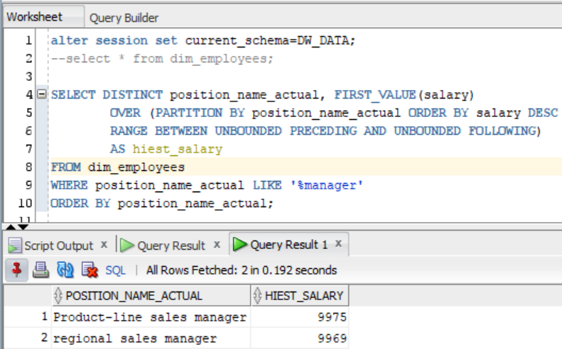

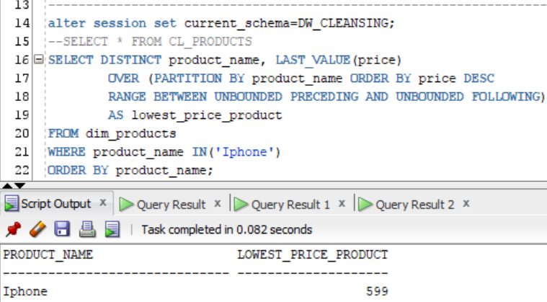

***Note.*** Here we used Last_value() function to see the minimum price for iPhone

2.2. Task 02: Create Ad Hoc SQL RANK, DENSE_RANK, ROWNUM

**The Main Task** is to create ad hoc SQL, which will split rows of data by Groups using Analytic Functions

**Required points:**

Use Analytic Function:

* RANK, DENSE_RANK, ROWNUM

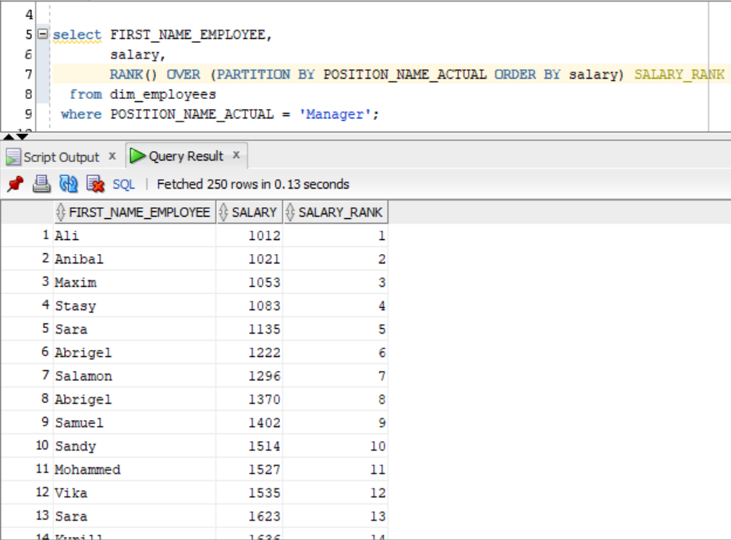

***Note.*** Here we use **RANK** analytic function to see ranked employees salaries

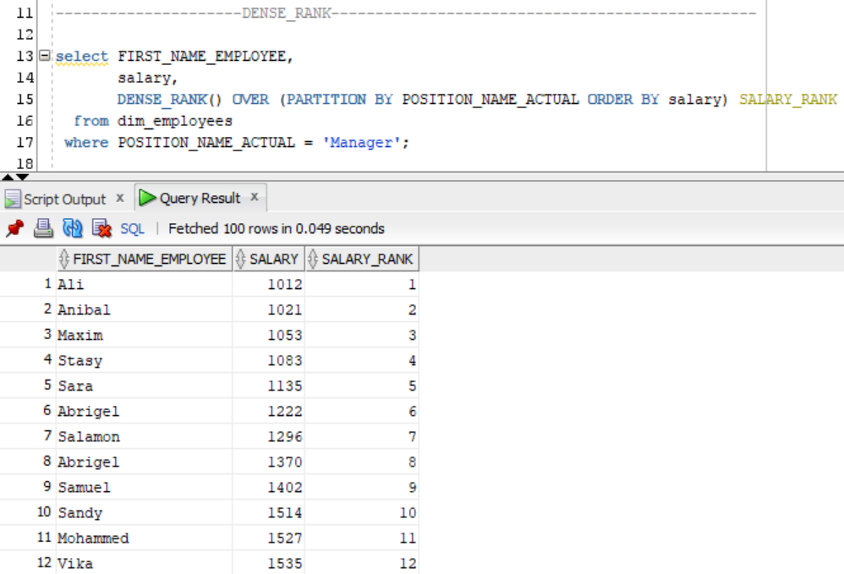

***Note.*** Here we use **DENSE_RANK** analytic function to see **DENSE_**ranked employees’ salaries

***Note.*** The difference between this two analytic functions is that **RANK** function may return a **non-consecutive ranking** if the values being tested **are the same**. Whereas, the **DENSE_RANK** function will always result in a **sequential ranking**.

2.3. Task 03: Create Ad Hoc SQL AGGREAGATE FUNCS

**The Main Task** is to create ad hoc SQL, which will analyze measurement using Analytic Functions

**Required points:**

Use Analytic Function:

* AGGREAGATE FUNCS (MAX, MIN, AVG)

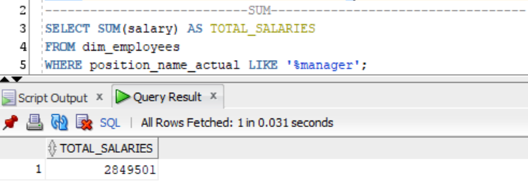

***Note.*** Here we can see what **amount of money** have we paid to all of our Manages

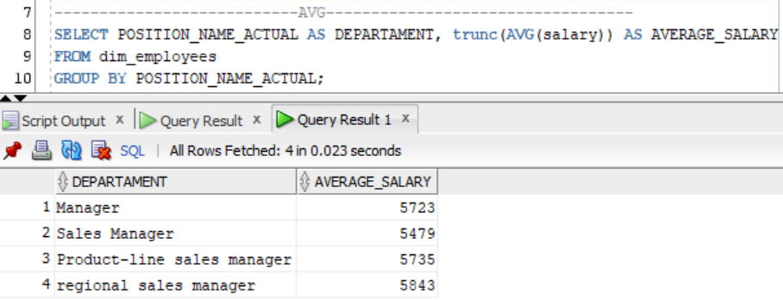

***Note.*** Here we can see **AVERAGE** salary we paid to our employees grouped by departments

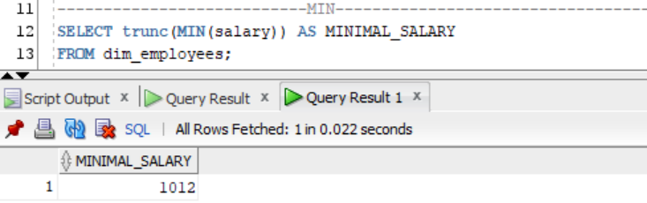

***Note.*** Here we can see **MINIMAL** salary we paid in company

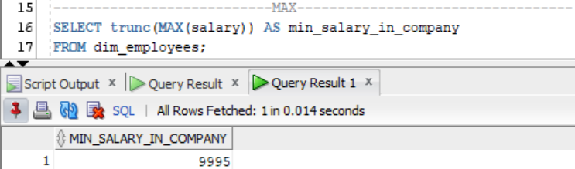

***Note.*** Here we can see **MAXIMUM** salary we paid in company

**Laboratory Work Summary:** At this laboratory work we practised usage of analytic and aggregative functions, such as:

* SUM
* AVG
* MAX
* MIN
* FIRST_VALUE
* LAST_VALUE
* RANK
* DENSE_RANK
* ROWNUM